Support to the Armenia-Turkey Normalization Process

EUROPEAN UNION
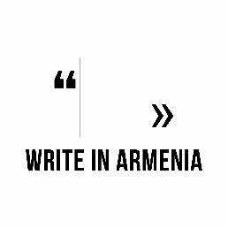

Application form

Applicant Information
Full Name:
 | Last | First
Date of birth:

Gender: | Male ☐ | Female ☐

Address:
 | Street Address |  |  |  | Apartment/Unit #
 | City |  |  | ZIP Code | Country
Phone: |  | Email

Education
Institution:
Specializatio:

From: |  | To: |  | Did you graduate? | YES  ☐ | NO  ☐ | Degree:

Current Employment, if any
Company/ Organization:
Position:

Blogs, websites, social media pages
You blog or website link:
Facebook page link:
Twitter page link:

Language skills

 | Fluent | Functional | Fair | Weak
English | ☐ | ☐ | ☐ | ☐
Other please add | ☐ | ☐ | ☐ | ☐

Your writing
Current focus or theme in writing:
Preferred writing style or form:
Publications, if any
Where did you learn about the program

Please submit this application, and the following documents:
- Motivation letter (in English). Please elaborate on the role
of cultural diplomacy in the dialogue between Armenia and Turkey
- your resume or CV (in English),
- a writing sample in your native language,
- and a writing sample (in English), to info@ariliterature.org and info@itef.com.tr by September 20, 2020.
Other notes:
- All applicants will be considered for the program without discrimination of race, color, religion, sex, sexual orientation, gender identity, national origin, or disability status.
- Please note that you will be placed in a room with a roommate. (Only same gender) roommates will be chosen by lottery drawing. If you have any special needs, physical restrictions, food restrictions, seasonal or other allergies or other conditions that program staff should be aware of please describe in the space below:

This activity takes place within the framework of the Sub-grants Scheme implemented by Eurasia Partnership Foundation as part of the “Support to the Armenia-Turkey Normalization Process: Stage 3” programme, funded by the European Union.

